

**Satellite Geodesy**

**“Astronomical position determination”**

Lab-1



1 |Jelin John(2924993)

( 4 9 9 3 )

**Contents**

|  |  |  |  |
| --- | --- | --- | --- |
| 1. | Aim | | 3 |
| 2. | Introduction | | 3 |
| 3. | Objective | | 4 |
| 4. | Methodology | | 4 |
| 5. | Explanation: | |  |
|  | 1. | Representation of co-ordinates in ICRS | 5 |
|  | 2. | Precession Correction | 6 |
|  | 3. | Earth rotation correction | 7 |
|  | 4. | ITRS Representation | 7 |
|  | 5. | Ellipsoidal Reference and Accurate position | 8 |
| 6. | Reference | | 8 |



2 |Jelin John(2924993)

( 4 9 9 3 )

**Aim**

To understand the different reference co-ordinate systems that use in satellite geodesy and thereby determine the astronomical position of a ground station / observer with respect to the Rauenberg datum.

**Introduction**

Appropriate, well defined and reproducible reference coordinate systems are essential for the description of Satellite motion, the modeling of observables and the representation and interpretation of result. The increasing accuracy of many satellite observation techniques requires a corresponding increase in the accuracy of the reference systems.

Reference coordinate systems in satellite geodesy are global and geocentric by nature, because the satellite motion refers to the center of mass of the earth. Terrestrial measurements are by nature local in character and are usually described in local reference coordinate systems. The relationship between all systems in use must be known with sufficient accuracy. Since the relative position and orientation changes with time, the recording and modeling of the observation time also plays an important role.



3 |Jelin John(2924993)

( 4 9 9 3 )

**Objective**

The main objectives of this lab are:

* Vector direction in ICRS frame
* Correction of Precession
* Earth rotation correction
* Transformation from ITRS to Ellipsoidal Co-ordinate System

**Methodology**



|  |  |  |
| --- | --- | --- |
| ICRS | Accurate |  |
| Position |  |
|  |  |



|  |  |  |
| --- | --- | --- |
| Precessio | Ellipsoidal |  |
| Co- |  |
| n |  |
| ordinate |  |
|  |  |
|  | System |  |

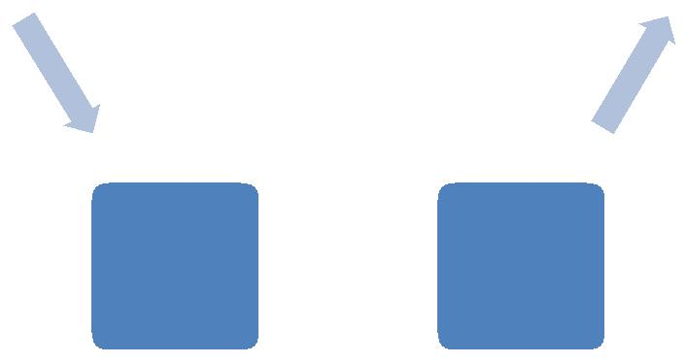

Earth



rotation ITRS correction



4 |Jelin John(2924993)

( 4 9 9 3 )

**Explanation:**

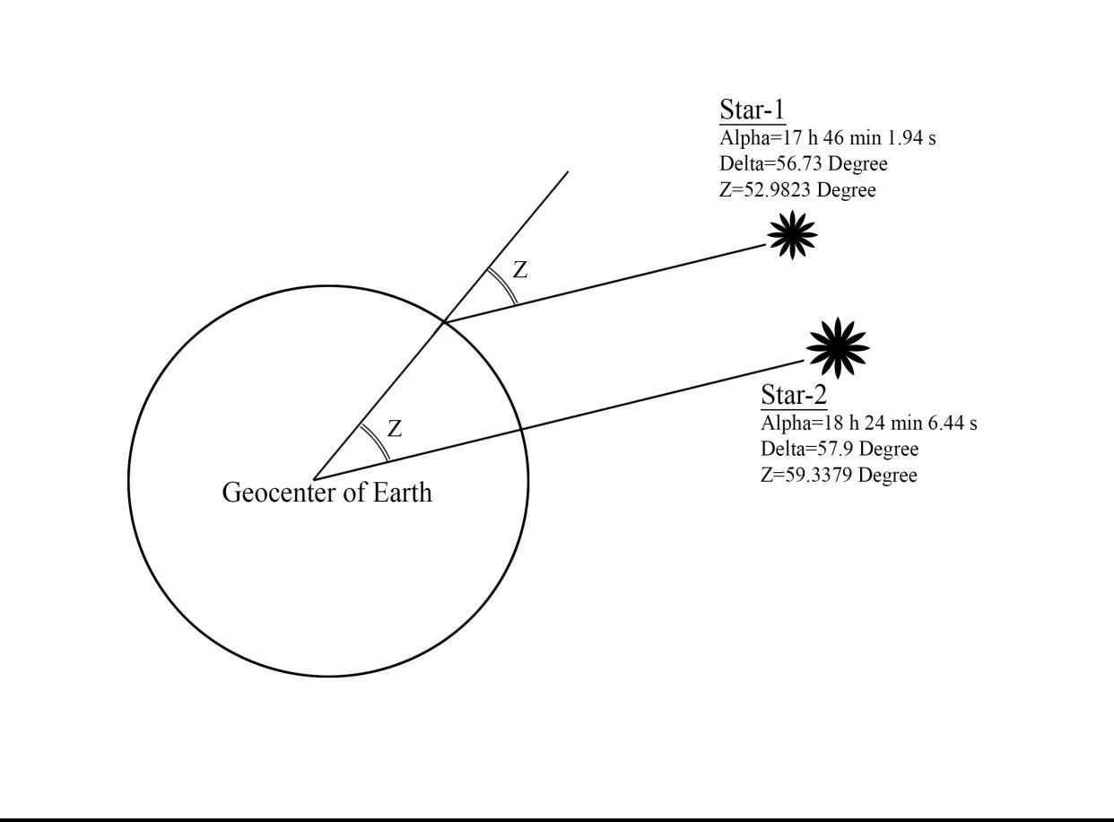

**Step(1): Representation of co-ordinates in ICRS**

The star positioning are usually in spherical co-ordinate system, and the given data’s have to be represented in the form of Cartesian. That is, transformation of spherical co-ordinates to Cartesian is needed. It gives ICRS vectors of two stars with X,Y and Z values:

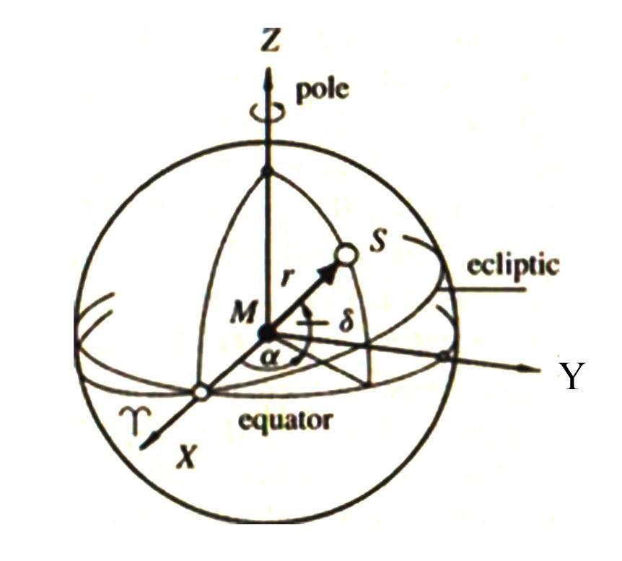

Fig:(2) Equatorial system in spherical astronomy



5 |Jelin John(2924993)

( 4 9 9 3 )

X=cos(delta)*cos(alpha)

Y=cos(delta)*sin(alpha)

Z=sin(delta)

Where, right ascension = alpha, declination = delta

ICRS1=[cos(delta1)*cos(alpha1);cos(delta1)*sin(alpha1);sin(delta1)];

ICRS2=[cos(delta2)*cos(alpha2);cos(delta2)*sin(alpha2);sin(delta2)];

**Step(2): Precession Correction**

Earth’s axis of rotation and its equatorial plane are not fixed in space, but rotate with respect to an inertial system. This results from the gravitational attraction of the Moon and the Sun on the equatorial bulge of Earth. The total motion is composed of a mean secular component (precession) and a periodic component (nutation).

They can be calculated by: ***P = R3(-z)R2(Theta)R3(-*Zeta)**

Where, z = (2306.2181 + 1.39656*T - 0.000139*T^2)* T...

+ (1.09468 - 0.000066* T)* T^2 +0.018203* T^3

Theta = (2004.3109 -0.85330* T - 0.000217* T^2) *T ...

- (0.42665-0.000217* T)* T^2 -0.041833* T^3

Zeta = (2306.2181 + 1.39656*T - 0.000139*T^2) *T...

+ (0.30188 - 0.000344*T) *T^2 +0.017998* T^3

To the transformation from a space fixed equatorial system to a CTS we need

3 Earth Rotation Parameters: R1,R2 and R3. By applying the transformations preces-sion (and if possible Nutation) we obtain *true coordinates.*

Nevertheless, we can compute conventional celestial ephemeris pole vectors for two stars:

CEP1=R3(-zA)*R2(thetaA)*R3(-zetaA)*ICRS1;

CEP2=R3(-zA)*R2(thetaA)*R3(-zetaA)*ICRS2;



6 |Jelin John(2924993)

( 4 9 9 3 )

**Step(3): Earth rotation correction**

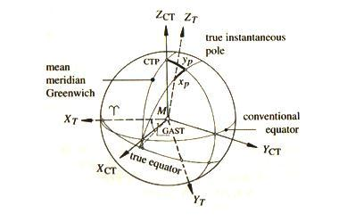

Fig(3): True instantaneous and mean conventional system

[HH MM SS]=GMST(yy,mm,dd,hh,0,0);

function [HH,MM,SS]=GMST(yy,mm,dd,hh,min,sec)

GM=mod(18.697374558+24.06570982441908*...

(G2JD(yy,mm,dd,hh,min,sec)-G2JD(2000,1,1,12,0,0)),24);

HH=floor(GM);

FM=(GM-HH)*60.0;

MM=floor(FM);

SS=(FM-MM)*60.0;

THETA=(HH+MM/60+SS/3600)*pi/12 ;

Earth rotation correction angle THETA can be calculated using above code.

**Step(4): ITRS Representation**

By multiplying rotation matrix 3 with celestial ephemeris pole vectors we can obtain complete ITRS co-ordinates of the two stars. In other words,

R(ITRS) =S*N*P*R(ICRS) Where, S= Rotation correction

P=Precession correction

N=Nutation correction (here we not considered this factor)

ITRS1=R3(THETA)*CEP1;

ITRS2=R3(THETA)*CEP2;



7 |Jelin John(2924993)

( 4 9 9 3 )

**Step(5): Ellipsoidal Reference and Accurate position**

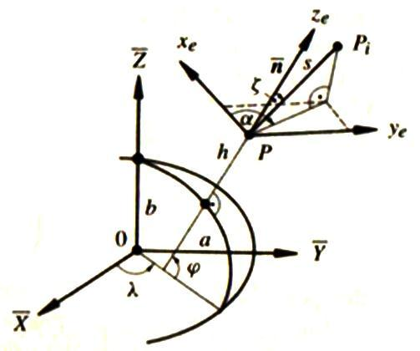

Fig(4): Global and local ellipsoidal system

As earth is closely approximated to an ellipsoid we need this co-ordinate sys-tem to facilitate a separation of horizontal position and height.Using the following code we will get the corresponding co-ordinates of the observer in the Earth.

e1=2*f1-f1^2; e2=2*f2-f2^2; N=a1/sqrt(1+e1^2*sin(thetap*pi/180));

XYZ=[N*cos(thetap)*cos(lambdap); N*cos(thetap)*sin(lambdap); N*(1+e1^2)*sin(thetap)];

rot=[1+11.99*10^-6 (3.3964/3600)*pi/180 -((0.5355/3600)*pi/180); - (3.3964/3600)*pi/180 1+11.99*10^-6 (-1.0778/3600)*pi/180; (0.5355/3600)*pi/180 -(-1.0778/3600)*pi/180 1+11.99*10^-6]; XYZ_NEW=[-588.196;-108.790;-378.506]+rot*XYZ;

**Reference**

1. Guenter Seeber- Satellite Geodesy – 2nd edition
2. wikipedia



8 |Jelin John(2924993)

( 4 9 9 3 )